The Usability Review

The considerations here are the user heuristics, the kinetic and cognitive loading when interaction with the intended design of group 09 (PR01-09). Each page will be reviewed on what would reflect easier for external user. And where parts should be changed and others that should stay will be discussed below.

**Home Page**

The choice of colour allows each of the elements such as the proposed location of the logo and name to stick out distinctly.

As a result, catches the eye of the user on entering the web page.

.

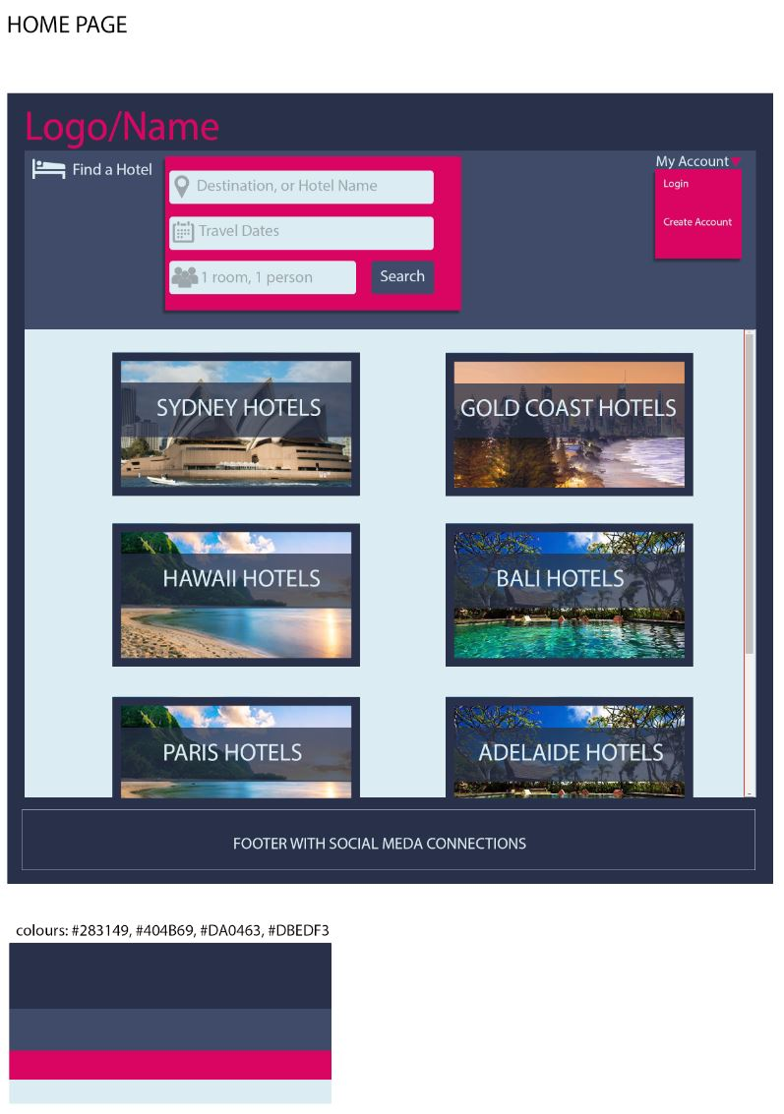

Further scanning the website, the search is shown below.   
Minimising the cognitive load for users who know what they are looking for.

While although having minimal displacement, it looks rather squarish and aesthetically modular.

And for those who don’t, don’t have to look far since it is on the single window size.

Coming back to the colour scheme chosen, it can be easily identified that while looking at the front page the designers went with a strong pink colour to outline the vital components of their website.

While the footer was not implemented, clearly seems that it will be statically visible when exploring.

The Account login interactive is not far and is quite visible to the user if in need to access the account.

**Login Page**

Keeping with a consistent colour scheme allows the vital pieces information to stand out on this page. Also, what part the page the user should interact with.

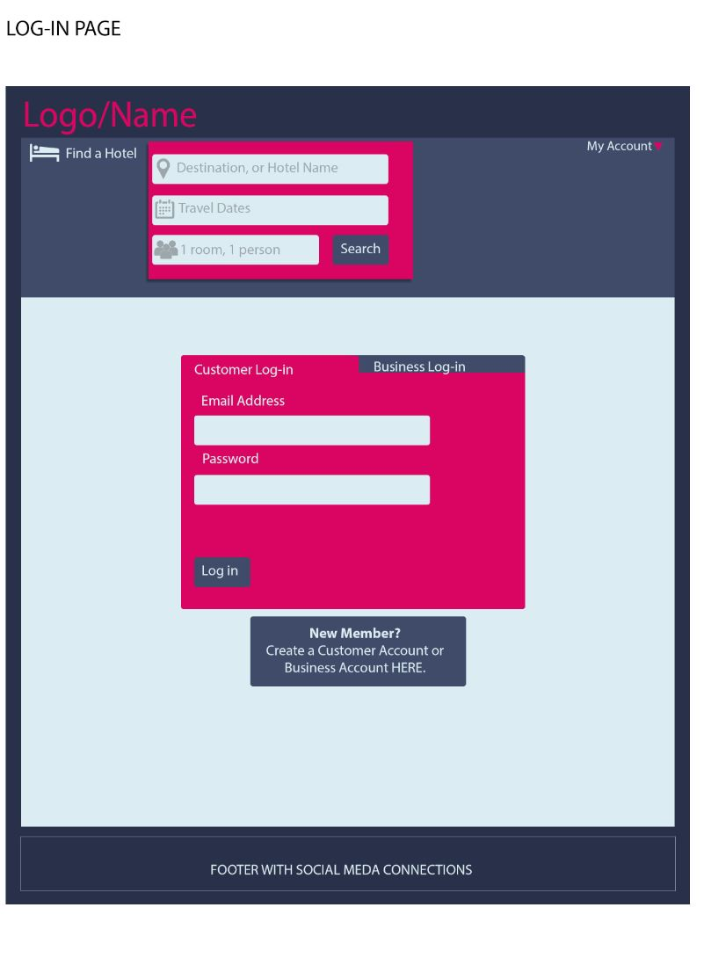

As a new customer, the new member registration is place central requiring less cognitive thinking.

The footer shows to be of static format as seen above for the header.

The design for the customer/business login is shown nicely in an almost browser tabulated format. This minimises the kinetic loading since the titles are adjacent to each other.

As seen in the home page, a consistent top banner, search with my account access is kept the same.

**Signup Page**

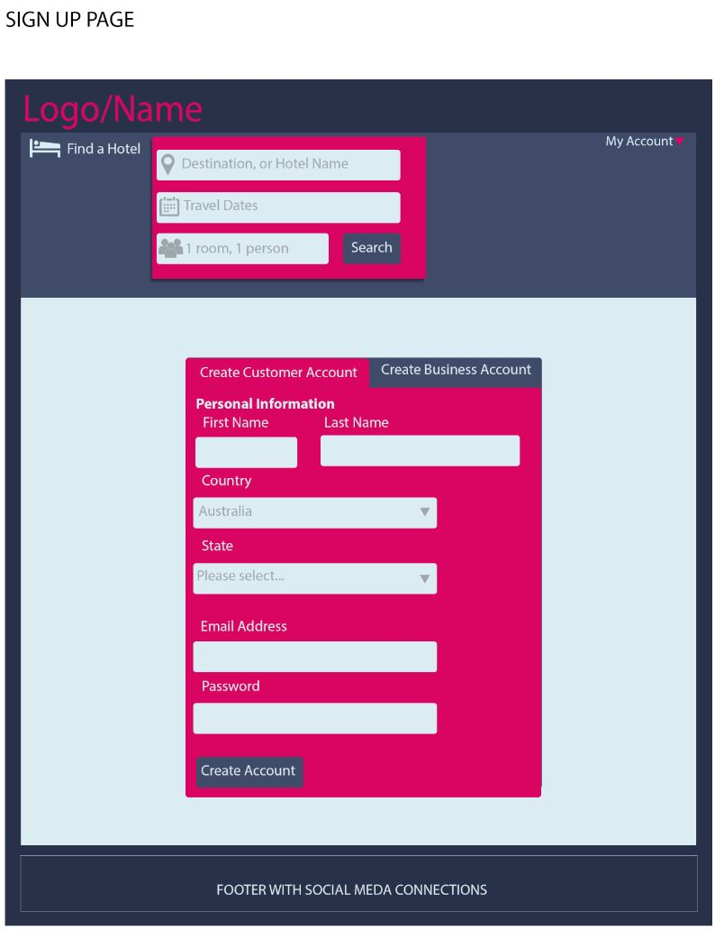

With users who have used hotel search websites will find that this is very simple and minimalistic.

The sign-up page follows a consistent format as the login page which decreases the additional cognitive analysis of a new page.

**Account Page**

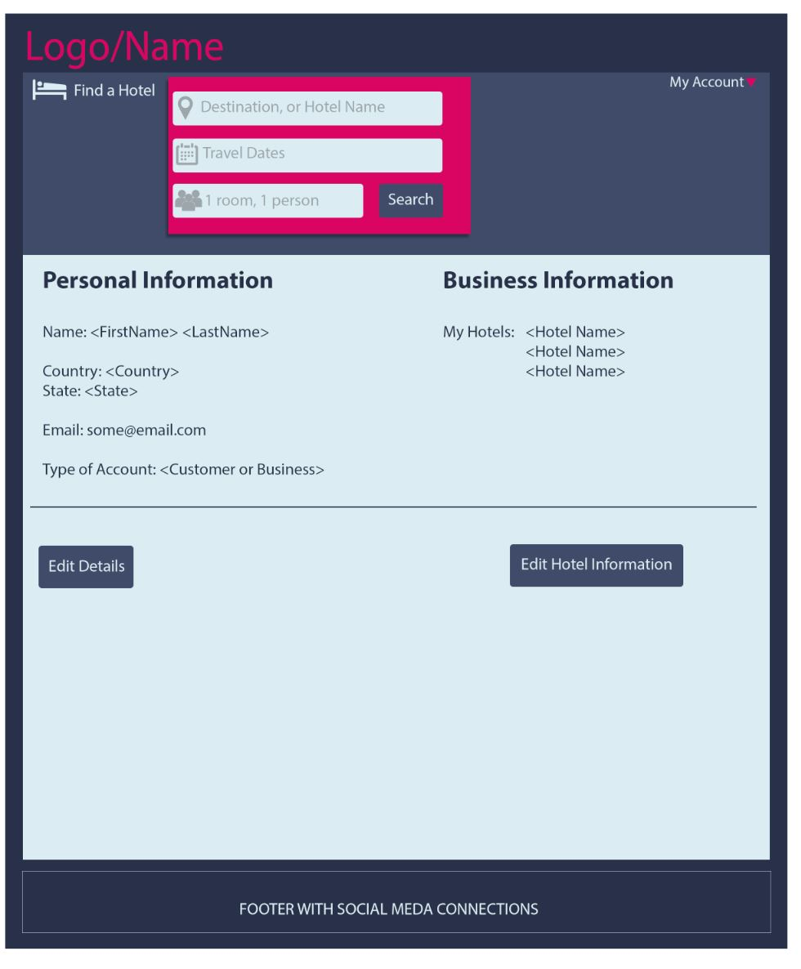

While this has hotels, it does not have much details about the individual hotel’s logistics and may require an additional page to see this.

As it is not described anywhere, additional thought had to go into thinking where to click to manage the hotels.

And as a result, may need improvement on this section.

With only the required criteria, it shows to be very basic.

As a simple account page, it has its required features but could modified to have more appeal as an interface.

**AddHotel Page**

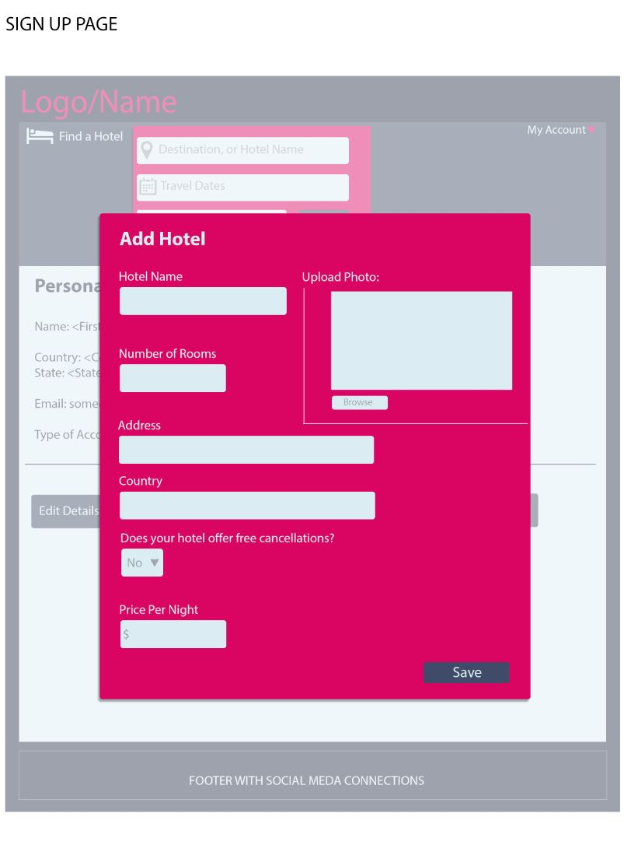

I believe the parameters and the picture could be re-ranged such as facebook format.   
Photo on top as a banner in this window for uploading and the details below it as to show the single file nature of filling out the form.

This stands out quite distinctly making it very clear what is needed to be input.

Although, it might be worth putting in grey “e.g. XXX” such as to tell the business owner what type of information is required. This decreases the additional thought of “what do they need?”.

**Hotel Page**

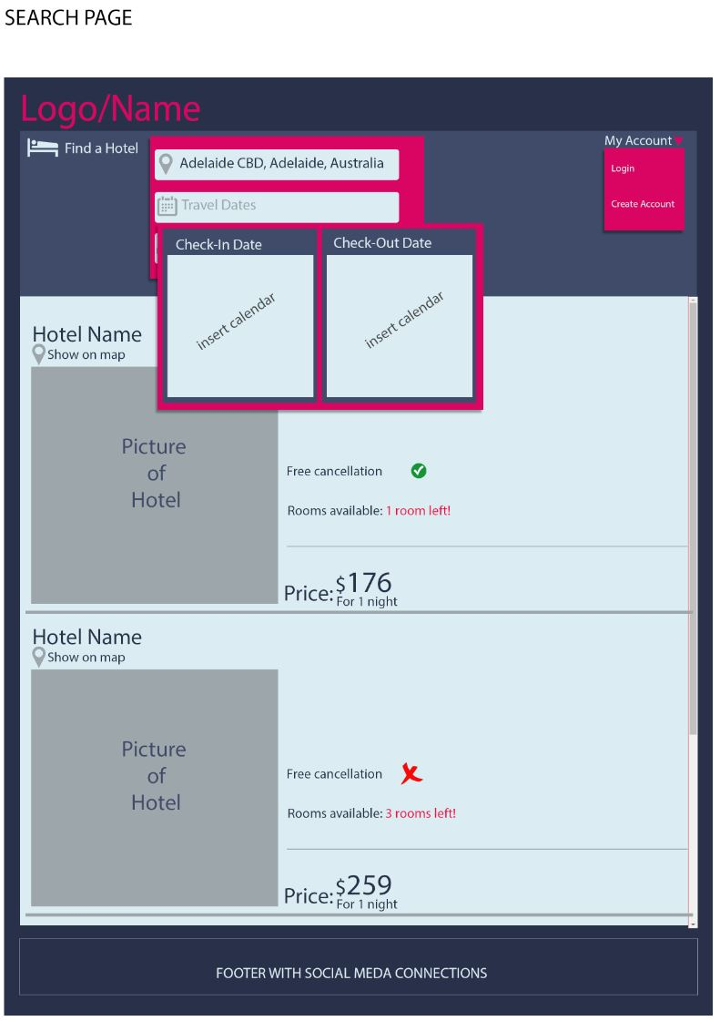

The results of the search are easily visible with minimal information, may increase cognitive load since the user can not make a judgement just yet without seeing more information.

Why not have the map on the right to occupy the space to show viewers the location of the hotel.

With a non-static calendar, I believe it has a blocking effect on other parts of the page. Here you may see that the hotel listing below is not visible.   
While this is fine on the front page, the search result page is found to be overlapping.